GIT LOG

NAME: Sushant Yerawar

ROLL NO:12041540

SUBJECT: STT2

→ git log

**commit 96e0461b4a18a82e1a86e359e111b98d3e69e6c3 (HEAD -> main, origin/main, origin/HEAD)**

**Author: Sushant Yerawar <sushantdyerawar2002@gmail.com>**

**Date: Thu Mar 10 03:44:10 2022 +0530**

**FINALLLLLL**

final reflog file :

->git log

commit c404bd3a8f56740674f31cf2f9757030a04bf91c (HEAD -> main, origin/main, origin/HEAD)

Author: PIYUSH PANCHOLI <76883890+08piyush@users.noreply.github.com>

Date: Thu Mar 10 10:01:57 2022 +0530

Update README.md

commit 39a88fe179d65acfb4ee1d0beff9ebd2319df133

Author: PIYUSH PANCHOLI <76883890+08piyush@users.noreply.github.com>

Date: Thu Mar 10 03:49:27 2022 +0530

Update README.md

commit 96e0461b4a18a82e1a86e359e111b98d3e69e6c3

Author: Sushant Yerawar <sushantdyerawar2002@gmail.com>

Date: Thu Mar 10 03:44:10 2022 +0530

FINALLLLLL

commit af918794d3ae20ef01f22cab692bb5d4dd586903

Author: Sushant Yerawar <sushantdyerawar2002@gmail.com>

Date: Thu Mar 10 03:41:26 2022 +0530

FINAL DONE

commit f0d7c0373d982c72e3df8a425c28f6944fc64c88

Author: piyushhh <pancholipiyush08@gmail.com>

Date: Thu Mar 10 03:32:10 2022 +0530

js file modified alltogether

commit 59ada3bc42c120be080df2155214eb3898d05fd3

Author: piyushhh <pancholipiyush08@gmail.com>

Date: Thu Mar 10 03:18:11 2022 +0530

random word genrated by this file

commit 29235a803198edf182d91884020c9b330115e001

Merge: 509330c 85927c5

Author: piyushhh <pancholipiyush08@gmail.com>

Date: Thu Mar 10 03:10:47 2022 +0530

json file added

Merge branch 'piyush' into main

commit 85927c50a1508f8e3eacb8b2ad8debee69207399

Author: piyushhh <pancholipiyush08@gmail.com>

Date: Thu Mar 10 03:10:12 2022 +0530

target words added for checking the word given by user

commit 509330c6655382b2b01c47238d78fe647ba2c2db

Merge: 4b76665 04f19da

Author: piyushhh <pancholipiyush08@gmail.com>

Date: Thu Mar 10 03:01:36 2022 +0530

css file rechecked

commit 4b76665b593508ee8fc90ea43fc4cfc980e26ff2

Author: piyushhh <pancholipiyush08@gmail.com>

Date: Thu Mar 10 03:00:13 2022 +0530

css file rechecked

commit 04f19da908897f173c5c6bad2f5f27cac79c252e

Author: piyushhh <pancholipiyush08@gmail.com>

Date: Thu Mar 10 02:58:47 2022 +0530

css file rechecked all fine 3

commit 2f11be98c60c936a40887a4f0c4fa203b2069a87

Merge: 38f9f5e 71f5192

Author: piyushhh <pancholipiyush08@gmail.com>

Date: Thu Mar 10 02:53:02 2022 +0530

merged with piyush

Merge branch 'piyush' into main

commit 71f519278cad2612bdb198749a92debdbe70bb18 (origin/piyush)

Author: piyushhh <pancholipiyush08@gmail.com>

Date: Thu Mar 10 02:51:12 2022 +0530

css fileupdated 2

commit 7f8431816e0cc13c6606983c9dfca3825023c2a8

Author: piyushhh <pancholipiyush08@gmail.com>

Date: Thu Mar 10 02:44:12 2022 +0530

modified css file 2

commit 38f9f5e79cf80b9b032cfa97ddf2f35124edbd17

Author: Sushant Yerawar <sushantdyerawar2002@gmail.com>

Date: Thu Mar 10 02:43:55 2022 +0530

Final

commit a4e943875a7e2c9b5d3743a9b196ab7a1fe98fd1

Merge: f9f4992 6177d56

Author: PIYUSH PANCHOLI <76883890+08piyush@users.noreply.github.com>

Date: Thu Mar 10 02:38:53 2022 +0530

Merge pull request #4 from 08piyush/piyush

Piyush

commit 6177d5690ba48743f9ede829a56d537bc021004b

Merge: 85bcfcf 6ef1d45

Author: piyushhh <pancholipiyush08@gmail.com>

Date: Thu Mar 10 02:37:43 2022 +0530

branch merged after edits

Merge branch 'main' into piyush

commit 85bcfcf6d6c84bf84783243893313abc2fe33181

Author: piyushhh <pancholipiyush08@gmail.com>

Date: Thu Mar 10 02:37:34 2022 +0530

css file modified 1

commit f9f4992243b67b66c126541df24274afa3e87522

Author: Sushant Yerawar <sushantdyerawar2002@gmail.com>

Date: Thu Mar 10 02:36:29 2022 +0530

h3

commit 6ef1d4588f58cf82769b9e9f4e3acb04865325cc

Author: Sushant Yerawar <sushantdyerawar2002@gmail.com>

Date: Thu Mar 10 02:34:41 2022 +0530

h2

commit 3fb60896c84f90a09d16cfff1f22a10e4a73684c

Author: Sushant Yerawar <sushantdyerawar2002@gmail.com>

Date: Thu Mar 10 02:28:31 2022 +0530

h1

commit ea45644a9806ef06ac6611ee2014d463df4e5f65

Author: Sushant Yerawar <sushantdyerawar2002@gmail.com>

Date: Thu Mar 10 02:26:05 2022 +0530

h1

commit 25d23d59f06ddb45d511ca66eb8f536c3bba3eaa

Author: piyushhh <pancholipiyush08@gmail.com>

Date: Thu Mar 10 00:46:03 2022 +0530

Revert "offline"

This reverts commit d9b78e2c59d3cc71a8cf315076cf998294e07c6f.

commit d9b78e2c59d3cc71a8cf315076cf998294e07c6f

Author: akashdeeep <akashdeep@iitbhilai.ac.in>

Date: Thu Mar 10 00:32:56 2022 +0530

offline

commit bb1048ecf5b1bac6ff5e4e35143f49f7596c5b94

Author: PIYUSH PANCHOLI <76883890+08piyush@users.noreply.github.com>

Date: Thu Mar 10 00:20:27 2022 +0530

Update README.md

commit 1169cdb3e0d51c9b320548ff53117239ee68668d

Author: PIYUSH PANCHOLI <76883890+08piyush@users.noreply.github.com>

Date: Thu Mar 10 00:19:35 2022 +0530

Update README.md

commit 252de30d81c565463ad915bd9d4445bb04503561

Author: Sushant Yerawar <sushantdyerawar2002@gmail.com>

Date: Wed Mar 9 22:49:54 2022 +0530

done 6

commit 92679af47b5efc6125b282d90d9c65d9247184cc (origin/htmlfile)

Author: piyushhh <pancholipiyush08@gmail.com>

Date: Wed Mar 9 20:47:43 2022 +0530

css file is completed

commit cb41097cc390625a18b53d4e2090dffe5d561260

Merge: ce69adf d7513ca

Author: piyushhh <pancholipiyush08@gmail.com>

Date: Wed Mar 9 20:28:43 2022 +0530

css file updated

Merge branch 'piyush' into main

.

commit d7513cab7a97452a1d8ff24bb5b2f313d87ec476

Author: piyushhh <pancholipiyush08@gmail.com>

Date: Wed Mar 9 20:28:18 2022 +0530

css file updated

commit ce69adf2b9c03705cc997771ef5c188ac28b2058

Merge: c10fa4b 5a89708

Author: PIYUSH PANCHOLI <76883890+08piyush@users.noreply.github.com>

Date: Wed Mar 9 20:11:18 2022 +0530

Merge pull request #3 from 08piyush/piyush

js file updated with one new function

commit 5a897082d6bf59c7648cf29d390c9c7988f3f3f5

Author: piyushhh <pancholipiyush08@gmail.com>

Date: Wed Mar 9 20:09:50 2022 +0530

js file updated with one new function

commit c10fa4b316fb69a030dc63390b248ebe7ffd721f

Merge: bac5bfa 234ce2d

Author: piyushhh <pancholipiyush08@gmail.com>

Date: Wed Mar 9 13:17:03 2022 +0530

readme resolved

commit bac5bfacbf653d7be36ce07c55edf46a01f42890

Author: piyushhh <pancholipiyush08@gmail.com>

Date: Wed Mar 9 13:14:51 2022 +0530

bug fixes in main branch

commit 234ce2d44751ab5d2e53bdc00661a5f96064d205

Author: piyushhh <pancholipiyush08@gmail.com>

Date: Wed Mar 9 13:13:06 2022 +0530

readme file updated and bug fixed in it

commit 16dfcb18dce4bdb42d11a247057478a6e7058199

Author: piyushhh <pancholipiyush08@gmail.com>

Date: Wed Mar 9 13:08:58 2022 +0530

bug fixed : extra diretory removed

commit aed36b6333f4471a3ea6a77b8e21495b1168bd49

Merge: 2fc3df1 d245dfd

Author: PIYUSH PANCHOLI <76883890+08piyush@users.noreply.github.com>

Date: Wed Mar 9 12:40:37 2022 +0530

Merge pull request #2 from 08piyush/piyush

html edited

commit d245dfd3533e1fc48af22548d0e10a23d8b5412e

Author: piyushhh <pancholipiyush08@gmail.com>

Date: Wed Mar 9 12:36:42 2022 +0530

html edited

commit 2fc3df1778c4bba954ca8deee164977175f2b6ed

Author: piyushhh <pancholipiyush08@gmail.com>

Date: Wed Mar 9 12:29:01 2022 +0530

function added in js file

commit 1293bc9422534d2442d00e469c8c4c8ce512bbf4

Author: Sushant Yerawar <sushantdyerawar2002@gmail.com>

Date: Wed Mar 9 02:02:42 2022 +0530

donecss4

commit 9527f5a261728a09b3e200ec17a2dda748f39c5e

Merge: 12a2f62 1f86c7a

Author: Sushant Yerawar <sushantdyerawar2002@gmail.com>

Date: Wed Mar 9 01:58:52 2022 +0530

Merge branch 'main' of https://github.com/08piyush/Wordibble

commit 12a2f629e15c8dc3a7cca3050e06d76e4525d50f

Author: Sushant Yerawar <sushantdyerawar2002@gmail.com>

Date: Wed Mar 9 01:16:29 2022 +0530

Revert "donecss1"

This reverts commit d2c78b2330dc95b8925a5d736662383e4738fd9e.

commit d2c78b2330dc95b8925a5d736662383e4738fd9e

Author: Sushant Yerawar <sushantdyerawar2002@gmail.com>

Date: Wed Mar 9 01:14:58 2022 +0530

donecss1

commit 9071b2bdb391c26dd72109814574296275f6ef35

Author: Sushant Yerawar <sushantdyerawar2002@gmail.com>

Date: Wed Mar 9 01:14:22 2022 +0530

donecss

commit 1f86c7aef78e2d1513398ac97d6c92d3e7bf046d

Author: piyushhh <pancholipiyush08@gmail.com>

Date: Wed Mar 9 00:59:12 2022 +0530

done

commit 61a8f06ab683884aef5d383fa5ccff0e84a6e136

Author: akashdeeep <akashdeep@iitbhilai.ac.in>

Date: Wed Mar 9 00:42:44 2022 +0530

js commit 4

commit c5e0abfa2c202d30d7b9ea2aba966ef91ccab872

Author: piyushhh <pancholipiyush08@gmail.com>

Date: Tue Mar 8 23:35:27 2022 +0530

.js file modified 1

commit e25f055af2159dea3ebb8ca4a8e7ecca36baea98

Author: Sushant Yerawar <sushantdyerawar2002@gmail.com>

Date: Tue Mar 8 23:17:30 2022 +0530

first js commit

commit 9a23e9489440834935de762b456c488086e5d6a4

Author: Sushant Yerawar <sushantdyerawar2002@gmail.com>

Date: Mon Mar 7 01:38:11 2022 +0530

html updated 2

commit 91aaf2115887b28e485977eb830a493e52eca358

Author: piyushhh <pancholipiyush08@gmail.com>

Date: Mon Mar 7 01:25:28 2022 +0530

changes updated 1 in html file

commit a93d2135126028055915afd612dd881c9230f6fe (origin/sushant)

Author: Sushant Yerawar <sushantdyerawar2002@gmail.com>

Date: Mon Mar 7 00:32:53 2022 +0530

html file commit

commit 951a8553557b033f6342dce8b5ad7d95952a636b

Author: PIYUSH PANCHOLI <76883890+08piyush@users.noreply.github.com>

Date: Sun Mar 6 23:51:27 2022 +0530

code file

commit 19e842f7ada70938a50a5b0c2dfd10ec178998c8

Author: PIYUSH PANCHOLI <76883890+08piyush@users.noreply.github.com>

Date: Sun Mar 6 23:50:05 2022 +0530

stylesheet

commit b1d27d016dfbf9f0794b06486a4a483141320fb1

Author: PIYUSH PANCHOLI <76883890+08piyush@users.noreply.github.com>

Date: Sun Mar 6 23:48:29 2022 +0530

html template

commit 54b7947fe9fcdc5baddd7b5ebe574b5bc9fd135c (origin/akash)

Author: akashdeeep <akashdeep@iitbhilai.ac.in>

Date: Sun Mar 6 17:33:34 2022 +0530

removing all

commit 39e9146d0a0dc50b0e2787f708335b4e64525982

Author: Sushant Yerawar <sushantdyerawar2002@gmail.com>

Date: Thu Mar 3 22:48:15 2022 +0530

My Commit

commit f5fbd6230d9e72c9d5436d56d6f9c4b330b1166e

Author: PIYUSH PANCHOLI <76883890+08piyush@users.noreply.github.com>

Date: Wed Mar 2 17:28:12 2022 +0530

Update README.md

commit b7fcb828ad9bf3396b53177b70e5a9cbe6a380f9

Author: PIYUSH PANCHOLI <76883890+08piyush@users.noreply.github.com>

Date: Wed Mar 2 16:14:02 2022 +0530

create primefile.py

This is main file of the project, the user needs to run this file to open the project.

commit de9d8a6d7aa20630977967bc2d57cebec3d220b0

Author: 08piyush <76883890+08piyush@users.noreply.github.com>

Date: Wed Mar 2 12:02:41 2022 +0530

**Initial commit**

**=========================================================================**

**===========================================================================**

**reflogs in between**

commit af918794d3ae20ef01f22cab692bb5d4dd586903

Author: Sushant Yerawar <sushantdyerawar2002@gmail.com>

Date: Thu Mar 10 03:41:26 2022 +0530

FINAL DONE

commit f0d7c0373d982c72e3df8a425c28f6944fc64c88

Author: piyushhh <pancholipiyush08@gmail.com>

Date: Thu Mar 10 03:32:10 2022 +0530

js file modified alltogether

commit 59ada3bc42c120be080df2155214eb3898d05fd3

Author: piyushhh <pancholipiyush08@gmail.com>

Date: Thu Mar 10 03:18:11 2022 +0530

random word genrated by this file

commit 29235a803198edf182d91884020c9b330115e001

Merge: 509330c 85927c5

Author: piyushhh <pancholipiyush08@gmail.com>

Date: Thu Mar 10 03:10:47 2022 +0530

json file added

Merge branch 'piyush' into main

commit 85927c50a1508f8e3eacb8b2ad8debee69207399

Author: piyushhh <pancholipiyush08@gmail.com>

Date: Thu Mar 10 03:10:12 2022 +0530

→ git reflog

* 96e0461 (HEAD -> main, origin/main, origin/HEAD) FINALLLLLL

* af91879 FINAL DONE

* f0d7c03 js file modified alltogether

* 59ada3b random word genrated by this file

* 29235a8 json file added

|\

| * 85927c5 target words added for checking the word given by user

* | 509330c css file rechecked

|\ \

| * | 04f19da css file rechecked all fine 3

| |/

* | 4b76665 css file rechecked

* | 2f11be9 merged with piyush

|\|

| * 71f5192 (origin/piyush) css fileupdated 2

| * 7f84318 modified css file 2

:...skipping...

* 96e0461 (HEAD -> main, origin/main, origin/HEAD) FINALLLLLL

* af91879 FINAL DONE

* f0d7c03 js file modified alltogether

* 59ada3b random word genrated by this file

* 29235a8 json file added

|\

| * 85927c5 target words added for checking the word given by user

* | 509330c css file rechecked

|\ \

| * | 04f19da css file rechecked all fine 3

| |/

* | 4b76665 css file rechecked

* | 2f11be9 merged with piyush

|\|

| * 71f5192 (origin/piyush) css fileupdated 2

| * 7f84318 modified css file 2

* | 38f9f5e Final

* | a4e9438 Merge pull request #4 from 08piyush/piyush

|\|

| * 6177d56 branch merged after edits

| |\

| * | 85bcfcf css file modified 1

* | | f9f4992 h3

| |/

|/|

* | 6ef1d45 h2

* | 3fb6089 h1

* | ea45644 h1

* | 25d23d5 Revert "offline"

* | d9b78e2 offline

* | bb1048e Update README.md

* | 1169cdb Update README.md

* | 252de30 done 6

* | 92679af (origin/htmlfile) css file is completed

* | cb41097 css file updated

|\ \

| * | d7513ca css file updated

| |/

:

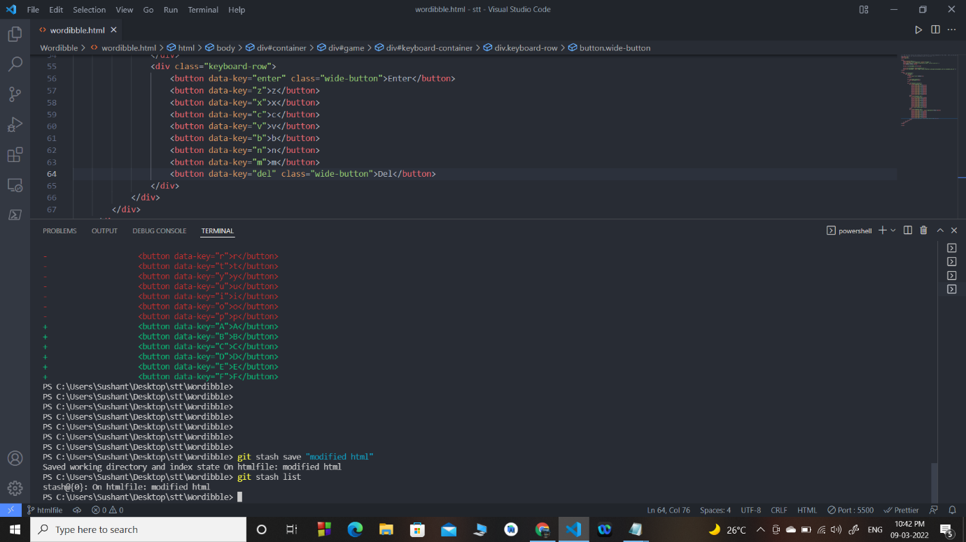

->git log

**commit 12a2f629e15c8dc3a7cca3050e06d76e4525d50f (HEAD -> main)**

**Author: Sushant Yerawar <sushantdyerawar2002@gmail.com>**

**Date: Wed Mar 9 01:16:29 2022 +0530**

**Revert "donecss1"**

**This reverts commit d2c78b2330dc95b8925a5d736662383e4738fd9e.**

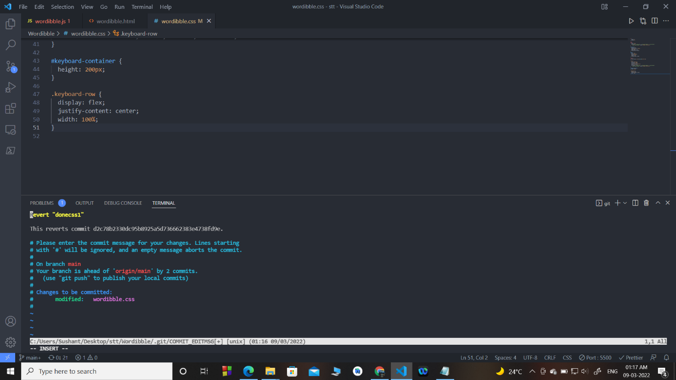

commit d2c78b2330dc95b8925a5d736662383e4738fd9e

Author: Sushant Yerawar <sushantdyerawar2002@gmail.com>

Date: Wed Mar 9 01:14:58 2022 +0530

donecss1

:...skipping...

commit 12a2f629e15c8dc3a7cca3050e06d76e4525d50f (HEAD -> main)

Author: Sushant Yerawar <sushantdyerawar2002@gmail.com>

Date: Wed Mar 9 01:16:29 2022 +0530

Revert "donecss1"

This reverts commit d2c78b2330dc95b8925a5d736662383e4738fd9e.

commit d2c78b2330dc95b8925a5d736662383e4738fd9e

Author: Sushant Yerawar <sushantdyerawar2002@gmail.com>

Date: Wed Mar 9 01:14:58 2022 +0530

donecss1

commit 9071b2bdb391c26dd72109814574296275f6ef35

Author: Sushant Yerawar <sushantdyerawar2002@gmail.com>

Date: Wed Mar 9 01:14:22 2022 +0530

donecss

commit c5e0abfa2c202d30d7b9ea2aba966ef91ccab872 (origin/piyush, origin/main, origin/HEAD)

Author: piyushhh <pancholipiyush08@gmail.com>

Date: Tue Mar 8 23:35:27 2022 +0530

.js file modified 1

commit e25f055af2159dea3ebb8ca4a8e7ecca36baea98

Author: Sushant Yerawar <sushantdyerawar2002@gmail.com>

Date: Tue Mar 8 23:17:30 2022 +0530

first js commit

commit 9a23e9489440834935de762b456c488086e5d6a4

Author: Sushant Yerawar <sushantdyerawar2002@gmail.com>

Date: Mon Mar 7 01:38:11 2022 +0530

:...skipping...

commit 12a2f629e15c8dc3a7cca3050e06d76e4525d50f (HEAD -> main)

Author: Sushant Yerawar <sushantdyerawar2002@gmail.com>

Date: Wed Mar 9 01:16:29 2022 +0530

Revert "donecss1"

This reverts commit d2c78b2330dc95b8925a5d736662383e4738fd9e.

commit d2c78b2330dc95b8925a5d736662383e4738fd9e

Author: Sushant Yerawar <sushantdyerawar2002@gmail.com>

Date: Wed Mar 9 01:14:58 2022 +0530

donecss1

commit 9071b2bdb391c26dd72109814574296275f6ef35

Author: Sushant Yerawar <sushantdyerawar2002@gmail.com>

Date: Wed Mar 9 01:14:22 2022 +0530

donecss

commit c5e0abfa2c202d30d7b9ea2aba966ef91ccab872 (origin/piyush, origin/main, origin/HEAD)

Author: piyushhh <pancholipiyush08@gmail.com>

Date: Tue Mar 8 23:35:27 2022 +0530

.js file modified 1

commit e25f055af2159dea3ebb8ca4a8e7ecca36baea98

Author: Sushant Yerawar <sushantdyerawar2002@gmail.com>

Date: Tue Mar 8 23:17:30 2022 +0530

first js commit

commit 9a23e9489440834935de762b456c488086e5d6a4

Author: Sushant Yerawar <sushantdyerawar2002@gmail.com>

Date: Mon Mar 7 01:38:11 2022 +0530

commit 12a2f629e15c8dc3a7cca3050e06d76e4525d50f (HEAD -> main)

Author: Sushant Yerawar <sushantdyerawar2002@gmail.com>

Date: Wed Mar 9 01:16:29 2022 +0530

Revert "donecss1"

This reverts commit d2c78b2330dc95b8925a5d736662383e4738fd9e.

commit d2c78b2330dc95b8925a5d736662383e4738fd9e

Author: Sushant Yerawar <sushantdyerawar2002@gmail.com>

Date: Wed Mar 9 01:14:58 2022 +0530

donecss1

commit 9071b2bdb391c26dd72109814574296275f6ef35

Author: Sushant Yerawar <sushantdyerawar2002@gmail.com>

Date: Wed Mar 9 01:14:22 2022 +0530

donecss

commit c5e0abfa2c202d30d7b9ea2aba966ef91ccab872 (origin/piyush, origin/main, origin/HEAD)

Author: piyushhh <pancholipiyush08@gmail.com>

Date: Tue Mar 8 23:35:27 2022 +0530

.js file modified 1

commit e25f055af2159dea3ebb8ca4a8e7ecca36baea98

Author: Sushant Yerawar <sushantdyerawar2002@gmail.com>

Date: Tue Mar 8 23:17:30 2022 +0530

first js commit

commit 9a23e9489440834935de762b456c488086e5d6a4

Author: Sushant Yerawar <sushantdyerawar2002@gmail.com>

Date: Mon Mar 7 01:38:11 2022 +0530

html updated 2

commit 91aaf2115887b28e485977eb830a493e52eca358

Author: piyushhh <pancholipiyush08@gmail.com>

Date: Mon Mar 7 01:25:28 2022 +0530

changes updated 1 in html file

commit a93d2135126028055915afd612dd881c9230f6fe (origin/sushant)

Author: Sushant Yerawar <sushantdyerawar2002@gmail.com>

Date: Mon Mar 7 00:32:53 2022 +0530

html file commit

commit 951a8553557b033f6342dce8b5ad7d95952a636b

Author: PIYUSH PANCHOLI <76883890+08piyush@users.noreply.github.com>

Date: Sun Mar 6 23:51:27 2022 +0530

code file

commit 19e842f7ada70938a50a5b0c2dfd10ec178998c8

Author: PIYUSH PANCHOLI <76883890+08piyush@users.noreply.github.com>

Date: Sun Mar 6 23:50:05 2022 +0530

stylesheet

commit b1d27d016dfbf9f0794b06486a4a483141320fb1

Date: Sun Mar 6 23:48:29 2022 +0530

html template

commit 54b7947fe9fcdc5baddd7b5ebe574b5bc9fd135c (origin/akash)

Author: akashdeeep <akashdeep@iitbhilai.ac.in>

Date: Sun Mar 6 17:33:34 2022 +0530

removing all

commit 39e9146d0a0dc50b0e2787f708335b4e64525982

Author: Sushant Yerawar <sushantdyerawar2002@gmail.com>

Date: Thu Mar 3 22:48:15 2022 +0530

My Commit

commit f5fbd6230d9e72c9d5436d56d6f9c4b330b1166e

Author: PIYUSH PANCHOLI <76883890+08piyush@users.noreply.github.com>

Date: Wed Mar 2 17:28:12 2022 +0530

Update README.md

commit b7fcb828ad9bf3396b53177b70e5a9cbe6a380f9

Author: PIYUSH PANCHOLI <76883890+08piyush@users.noreply.github.com>

Date: Wed Mar 2 16:14:02 2022 +0530

create primefile.py

This is main file of the project, the user needs to run this file to open the project.

commit de9d8a6d7aa20630977967bc2d57cebec3d220b0

Author: 08piyush <76883890+08piyush@users.noreply.github.com>

Date: Wed Mar 2 12:02:41 2022 +0530

Initial commit

===============================================================================

===============================================================================